Control of Gantry Crane

Gantry cranes are widely used for multiple of purposes, from production facilities to loading and unloading huge cargo containerships. Even though there exist different types of loads, it is almost always of interest to reduce sway during travel, for structural and safety reasons. This project will investigate methods of controlling the gantry crane to reduce travel time and maximum sway angle. The project will use Matlab/Simulink to send and receive sensor and motor signals from a small-scale gantry crane setup located in the electronics lab of Aalborg University Esbjerg. The test setup is already constructed and ready for control implementation via Simulink desktop real time. The system is characterized by having one input (voltage to motor) and two outputs (sledge position and sway angle).
The project must include:
- First principles modeling of the gantry crane (DC motor, trolley, and pendulum).
- Control implementation and comparison (PID)
  - Serial control
  - Parallel control
The project can include:
- Investigate sensors and actuators, their signals, conversions, advantages, limitations.
- Review the performance of the designed controllers.
- Review of tuning methods.

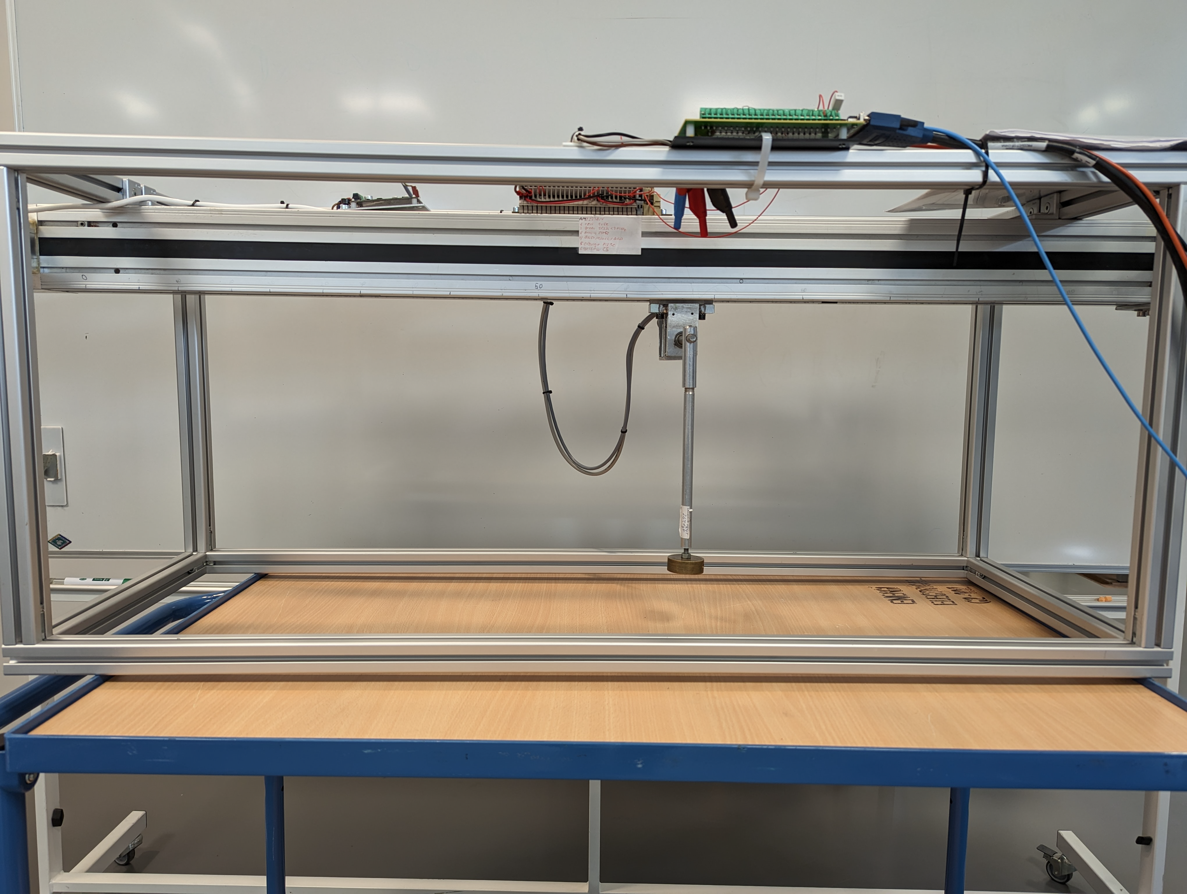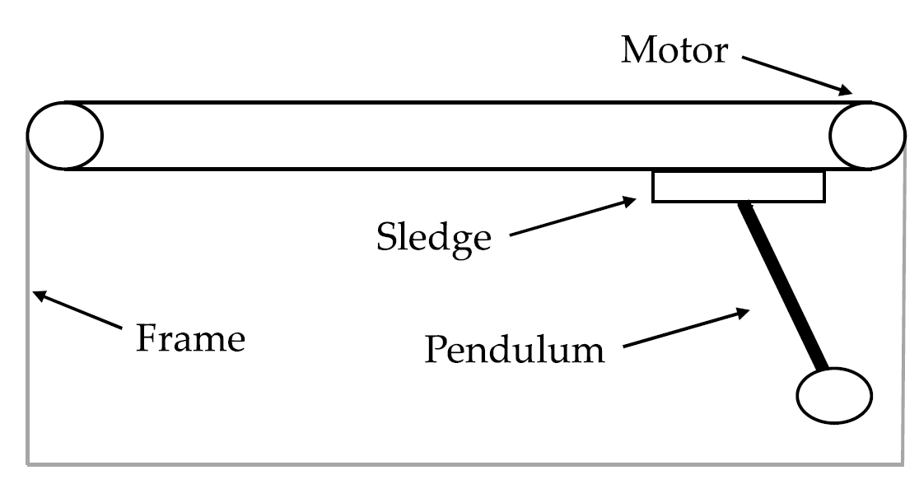

This project will be supervised by Mads V. Bram: mvb@energy.aau.dk

